TOOL - Businessplan

Businessplan
Link: http://www.businessplan.ch/en
The leading Swiss tool
Think it. Plan it. Do it.
Video Tour
More than 10,000 users in Switzerland
Recommended by banks, investors and universities


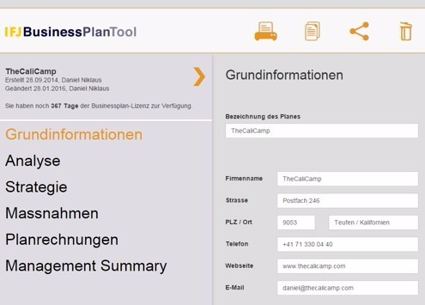

Get a quicker start
with templates and tips
Real templates and tips in each chapter make creation of your own business plan even easier – whether you’re a local SME or an international technology start-up.
Download a free template plan
Free basic business
plan workshop
Do you have a business idea that you want to systematically think through, check and evaluate the financial consequences? Then develop your own business plan live with the help of the free IFJ BusinessPlan Tool and learn the ins and outs of business plans in a compact workshop setting.
Find a course date




Free advanced business plan
intensive course
Already have a handle on the basics of business plans? Would you like to take a deeper and more professional look at the material? Then take our intensive course to find out how to implement a business idea for lasting effect.
This course is held in German.
Find a course date
Major benefits
for your security
- Reliable data protection thanks to Swisscom hosting in Switzerland
- Business plans, step by step
- Meaningful financial planning
- Export into Word at the touch of a button
- The business plan standard that banks, investors and entrepreneurs prefer
- Free courses
Start now for free


Aus <http://www.businessplan.ch/en>

